Rotary Club of Kathmandu Mid-Town
Breakfast Chatter
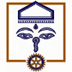



30 December 2011 The Weekly Bulletin of Rotary Club of Kathmandu Mid-Town Bc-12.30/011-12

District: 3292 Web: www.rotarymidtown.org.np Club Id : 26776

DECEMBER IS THE FAMILY MONTH
Rotarians, clubs, and districts worldwide are encouraged to demonstrate their commitment to family and community through projects, activities, and events in celebration of Family Month .

Rotary family is important because it allows us to build lifelong friendships, enhances our personal families’ relationships, builds world understanding and peace, improves international solidarity and tolerance, contributes to membership growth, contributes to diversity of age, gender, race, ethnicity, culture, religion and profession, improves Rotary’s public image, strengthens clubs and their commitment to service.

Importance of Family – Realize it Before It’s Too Late
Family is very imperative part of our daily life. It helps us in improving our overall personality. It also helps us in shaping our life. It teaches us the value of love, care, affection, self-confidence and truthfulness and provides us tools & suggestions which are essential to get success in life.

Wishing you all a very
Happy New Year
2012
Click here ⇩

23 December, Friday:
Guest Speaker Maris Siagamspisgm, Thai Ambassador to Nepal, gave a very interesting talk on role of private sector for bringing in rapid socio-economic development in the country. HE narrated Thai experience in solving many of the problems which Nepal is currently facing.

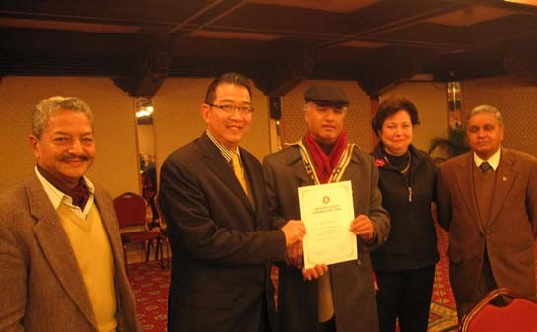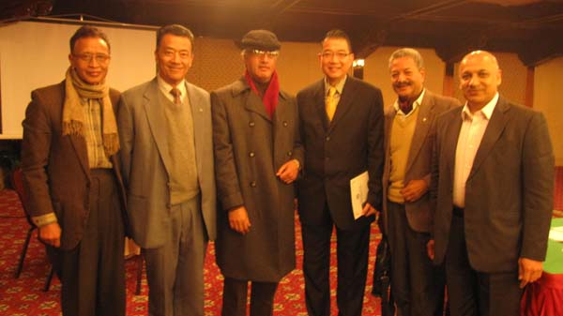
President Dr. Som handing over a Certificate of PP RR, CP Dr Roop, President Som, IPP Pratap
Appreciation to the Guest Speaker Thai Ambassador and PP CK with Thai Ambassador Maris after
HE Maris Sangiampongsa flanked by IPP Pratap, the meeting.
VP Isa and Secretary Amar.

Weekly Meetings and Programs :
Date | Program/Speaker | Program/Topics of Presentation
30 December 2011 | Steven Dawa Sherpa | Great Himalayan Trek

30 December, Friday:
Dawa Steven Sherpa will be providing a very interesting talk on Great Himalayan Trek. Don’t miss it !

Top five Rotary stories of 2011
From the tsunami in Japan to the launch of strategic partnerships that will help Rotary expand its reach, 2011 was an eventful year for Rotary International and Rotarians. As the year winds down, we share our list of the top five Rotary news events of 2011.
1. Tsunami strikes Japan
Rotary clubs and districts worldwide mobilized to bring aid to victims of the devastating earthquake and tsunami that struck Japan on 11 March. The 9.0-magnitude quake, the strongest in Japan's history, and the resulting tsunami caused widespread destruction, paralyzing much of the northern coast.
In response, The Rotary Foundation established the Rotary Japan 2011 Disaster Recovery Fund, which has raised almost US$6 million for long-term recovery projects.
The fund is being administered by a committee of local Rotarians who are identifying communities’ needs, managing the distribution of funds, overseeing and reporting on project implementation, and ensuring proper stewardship. Rotarians have already completed 10 projects with $400,000 from the recovery fund.
In addition, clubs and districts held benefits in support of tsunami victims, including a concert organized by Miki Okubo, a Rotary Foundation Ambassadorial Scholar from Japan studying in Paris.
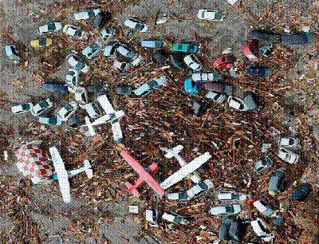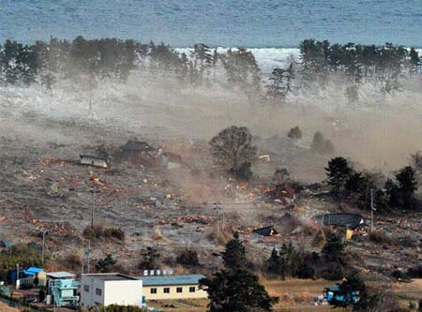
(To be Cont’d) Source: Rotary International News

World most expensive horse !
Green Monkey, descendant of two Kentucky Derby winners, was purchased as a two-year-old race horse at Calder Race Course by Demi O’Byrne at a price of $ 16 millions. The winner of the auction had high hopes for the young horse. But the horse flopped never winning a race.
Source: The Himalayan Times

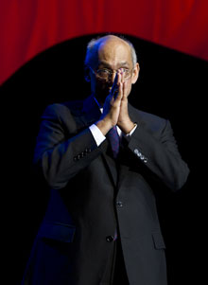
We cannot share peace with others if we do not have it to give. We cannot look after
the whole world without first looking after those closest to us: our families, our clubs,
and our communities.
RI President Kalyan Banerjee

On Lighter Side :
Juggling 5 balls
Imagine life as a game in which you are juggling some five balls in the air.
They are
Work, Family, Health, Friends and Spirit –
and you are keeping all of these in the air.
Work is a rubber ball. If you drop it, it will bounce back.
But the other four balls – Family, Health, Friends and Spirit – are made of glass.
If you drop one of these, they will be irrevocably scuffed, marked, nicked, damaged or even shattered. They will never be the same. You must understand that and strive for it.
Work sincerely, and efficiently when you are at your work assignment so that you can leave on time. Give sufficient time to your family, friends and have proper rest.
Value has a value only if its value is properly valued !
Bryan Dyson

Shopping bags! They may be useful in your e-shoppings!

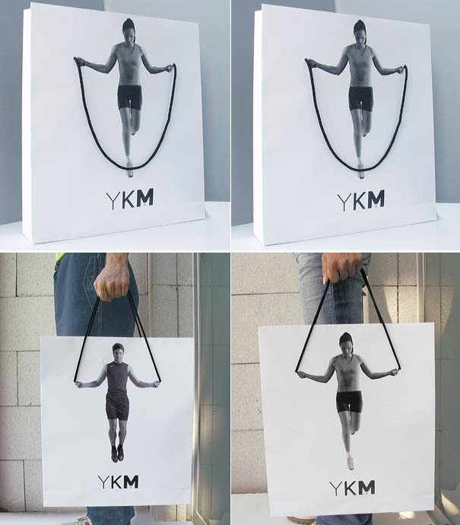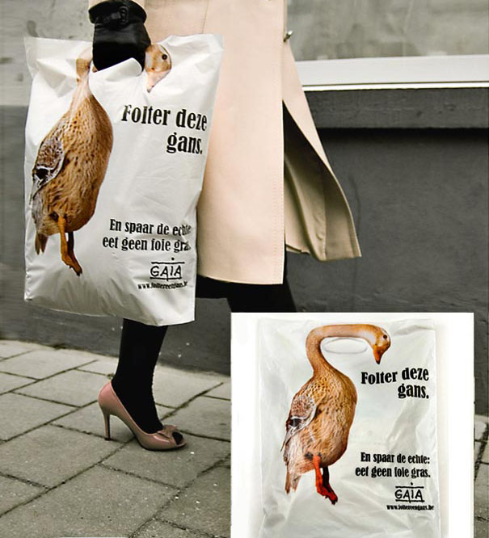

Please send project/activity information, suggestions and photos etc to :
BC Editor: RR Shrestha email: rryes@wlink.com.np

30 December 2011 The Weekly Bulletin of Rotary Club of Kathmandu Mid-Town bc-12.30/011-12

